**Title:** Sp21 Spring Break Camp,Printed Circuit Board Design

**Instructor:** Jonathan Valvano [valvano@mail.utexas.edu](mailto:valvano@mail.utexas.edu)

**Class:** MTWTF, 10-11am, March 15-19

**Office Hours** MTWTF, 11-noon, March 15-19

**Room:** Zoom link on EE319K/EE319H Canvas zoom page

**EE319K/EE319H MWF7-8pm** office hours see EE319K Canvas syllabus page

**Disclosure:** There will be no student cost, no face to face student contact, and no grades. This camp is completely optional. It will not affect your regular EE319K/EE319H grade.

**Description:** Printed circuit board (PCB) design process; tools for PCB layout and fabrication; standardization; design for testability.

**Overview:** This hands-on course will walk through the process of PCB design, layout, construction, and test. Each team of two or three students will layout an EE319K/EE319H PCB that contains all the circuits required to complete Labs 6, 7, 8, and 10. The circuit design and software will be presented as part of regular EE319K/EE319H, but in this camp, students will manufacture the interconnections as a printed circuit board. Students will translate the electrical circuit into a PCB design, where most of their parts are selected from a starter file containing the parts already in your EE319K/EE319H lab kit. Students will learn to consider issues like drill holes, high current routing, standard values, tolerances, and testing. Students draw the electrical circuits in schematic form as the first assignment, performed individually. If you complete assignment 1 by Wednesday 10am, teams of 2 or 3 will be formed and the team will create one PCB design. Teams who complete their PCB layout by Friday 3/19 10am will have their board manufactured, making three copies. There are two 20-pin headers and some hardware that will be distributed with the PCBs. Since all students will create similar circuits, students will evaluate each other’s layout. It takes about 2 weeks to get PCB boards produced, so the PCBs should be back in time for you to use it in Labs 8, 9, and 10. To use the PCB for EE319K/EE319H you will need to solder the kit components onto the PCB.

**Signup:** (no actual commitment) <https://docs.google.com/spreadsheets/d/1JlcZKAabRoVn5QLbOWWUosIQ9vHJUVuZPtwNsVPdiMY/edit?usp=sharing>

**Equipment:** Students must have a laptop that can run Eagle by Autodesk.

**Installations prior to class on Monday:**

Option A) Register a student account: watch <https://youtu.be/KWYJ02tlG4I>

<https://www.autodesk.com/education/free-software/eagle>

Install latest version of educational version Eagle (do not spend any money)

Download and install **Autodesk_EAGLE_9.6.2_English_Win_64bit.exe**

<https://www.autodesk.com/products/eagle/>

Option B) Install latest version of free/limited version Eagle (do not spend any money)

**Eagle quits immediately on Launch**

<https://knowledge.autodesk.com/support/eagle/troubleshooting/caas/sfdcarticles/sfdcarticles/Eagle-crashes-seconds-after-launching-splash-screen.html>

**Bookmark these two tutorials prior to class on Monday:**

<https://learn.sparkfun.com/tutorials/using-eagle-schematic>

<https://learn.sparkfun.com/tutorials/using-eagle-board-layout>

**Computer work prior to class Monday:** <https://youtu.be/i4pFbAbk2hY>

Create a folder called **Library** on your computer and copy this file into it

<https://www.dropbox.com/s/admu7w03xiaplje/EE445L.lbr?dl=1>

Create a folder called **Design** on your computer and copy these two files into it

<https://drive.google.com/drive/folders/1kzL1rcTRE0Ty1l9V_MoXqrGKaG6G--_i?usp=sharing>

EE319KLabKit.sch

EE319KLabKit.brd

Rename these two files with your EID (extensions are different, name must match)

Create a folder called **Datasheets** on your computer and copy these 8 files into it<https://drive.google.com/drive/folders/1-5_a7SrrhwGThlpLn_bKOAbU1F1jL4xG?usp=sharing>

**More Eagle instructions** <http://www.instructables.com/id/Turn-your-EAGLE-schematic-into-a-PCB/>

**Optional additional Eagle Libraries**

Sparkfun <https://learn.sparkfun.com/tutorials/how-to-install-and-setup-eagle/using-the-sparkfun-libraries>

Element14 <https://github.com/steakunderscore/eagle-cad-libraries> <https://www.element14.com/community/community/cadsoft_eagle/eagle_cad_libraries>

**Monday Goals:**

1) Overall plan for the week

Monday-Tuesday schematic

Wednesday-Thursday PCB

Friday PCB design reviews

2) Installing Eagle (come to office hours 11am or 7pm if stuck)

3) Linking EE445L library

4) Overview of EE319K/EE319H Labs 6,7,8,9,10

5) Eagle commands

Grid and layers

Parts have a red cross to select it

Info of a part

name, value, position, rotation, footprint on PCB

Some parts are not parts at all 3V3, Gnd

Move

Rotate

Group-Move

Copy

Delete

Add part: 3-pin header

6) Build switch interfaces: 2 is minimum, 4 is awesome

**Move** switches and 10k resistors together

**Add net** to complete circuit

**Name** net to connect to LaunchPad pins PE3-0

**Info** on switches to document functionality

7) Build LED interfaces: choose how many LEDs you want

**Move** LEDs and 470 resistors together

**Add net** to complete circuit

**Name** net to connect to LaunchPad pins PA2-5

**Info** on LEDs to document functionality

8) Build DAC/speaker interfaces

**Move** Jack, three 1.5k, three 12k, 24k, and 47k resistors together

**Add net** to complete circuit

**Name** net to connect to LaunchPad pins PB5-0

**Tuesday Goals:**

9) Name date on schematic

10) **Copy** testpoint, place near DAC/JACK, Info it to document functionality

11) Build OLED interface with 1.5k resistor

12) Build slide pot interface with TP

13) Build Lab 9 serial communication interface (optional)

14) Scope connections 3-pin header connecting PD3 to PD2 or PD3 to DACout

15) Optional stuff: Sparkfun <https://www.sparkfun.com/products/9032>

Add another library and connect joystick

16) Look at PCB view and develop a strategy for game layout

**Wednesday Goals**

17) Form teams for PCB layout; put your names here in this tab

<https://docs.google.com/spreadsheets/d/1JlcZKAabRoVn5QLbOWWUosIQ9vHJUVuZPtwNsVPdiMY/edit#gid=1957258355>

18) Upload SCH (finished) and BRD (not started) into this folder; name your files with your EID

You should have gotten an email invite to a box folder

19) Place parts to (show layers and grid again)

0) avoid overlaps;

1) make fun to play;

2) minimize airwire length;

3) reduce airwire crossings.

20) Check airwires, does it make sense?

21) Check nets, does it make sense?

22) Execute DRC (checking for overlaps)

23) Route ground with 20mil trace, make a star pattern (no circles)

Making via with middle button

Changing width

24) Execute DRC

25) Route +3.3V and +5V, make a star pattern (no circles)

26) Execute DRC

**Thursdays Goals**

17 revisit) Finalize teams for PCB layout; put your names here in this tab

<https://docs.google.com/spreadsheets/d/1JlcZKAabRoVn5QLbOWWUosIQ9vHJUVuZPtwNsVPdiMY/edit#gid=1957258355>

27) Print top

28) Print bottom, mirrored

29) glue to cardboard and arrange parts

30) Route signals with 8mil traces, make sure it makes sense

31) Execute DRC

32) Clean up silk, make sure everything as label

33) Put names on top and bottom

34) Execute DRC

Optional Image on Silk

Paint BMP monochrome bitmap

run import-bmp

select black for image (which ever you wish to see)

scale from 0.1 to 1 with trial and error

start layer is 21

**Friday Goals**

35) Upload your SCH/BRD files to shared box folder with EID_EID names

36) Review student PCB designs

37) Upload PCB to <https://oshpark.com/>

38) Make gerbers and upload zip to [JLCPCB: PCB Prototype & PCB Fabrication Manufacturer](https://jlcpcb.com/)

39) make PCB width less than 100mm, upload PCB to <https://dirtypcbs.com/store/pcbs>

41) Advanced Circuits www.4pcb.com

40) Due Monday 9am

**Get PCB**

**Get Parts**

JV will mail two 2by20 headers, two 1by3 header, two 2-pin jumper, 4 standoff

Students use parts they already have

**Soldering**

Collect solder, soldering iron, cutter, solder paste, patience

Collect all parts: use an ohmmeter to check resistor values

<https://www.instructables.com/Simple-PCB-soldering/>

<https://www.youtube.com/watch?v=AqvHogekDI4>

We will set up soldering station in EER EE319K/EE319H/EE302 Lab EER 1.826

One at a time in the Remove

Solder the parts in reverse size order (resistors first and OLED last)

**Assignment 1:** Draw EE319K/EE319H circuits in Eagle for labs 6,7,8,9,10 in one SCH file

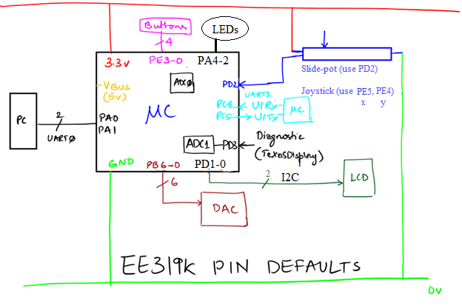

Expand your Lab 3 circuits to have four switches and three LEDs

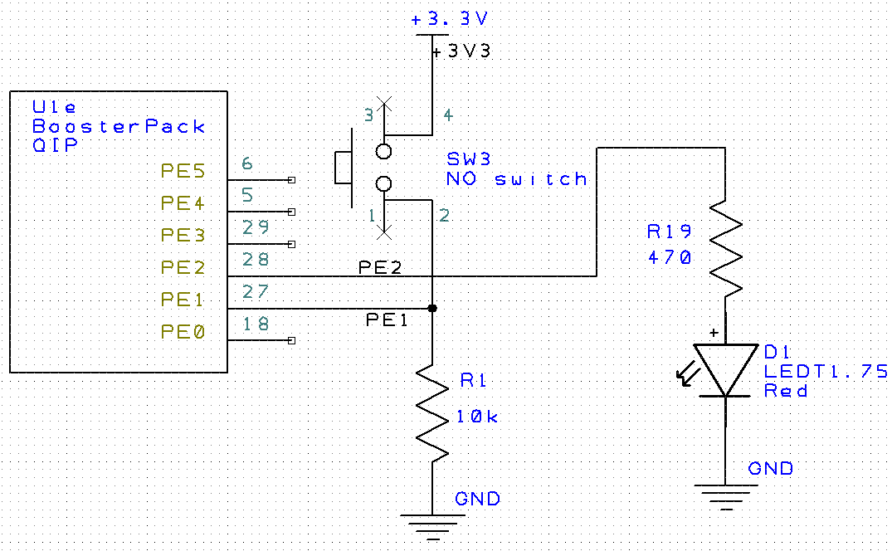

*Figure 3.8. PCB Artist drawing showing Port E, 3.3V power, a 10kΩ resistor, a switch,, an LED, a 470Ω resistor, and ground.*

Draw a 6-bit DAC using three 1.5k, three 12k, one 24k and and one 47k resistor.

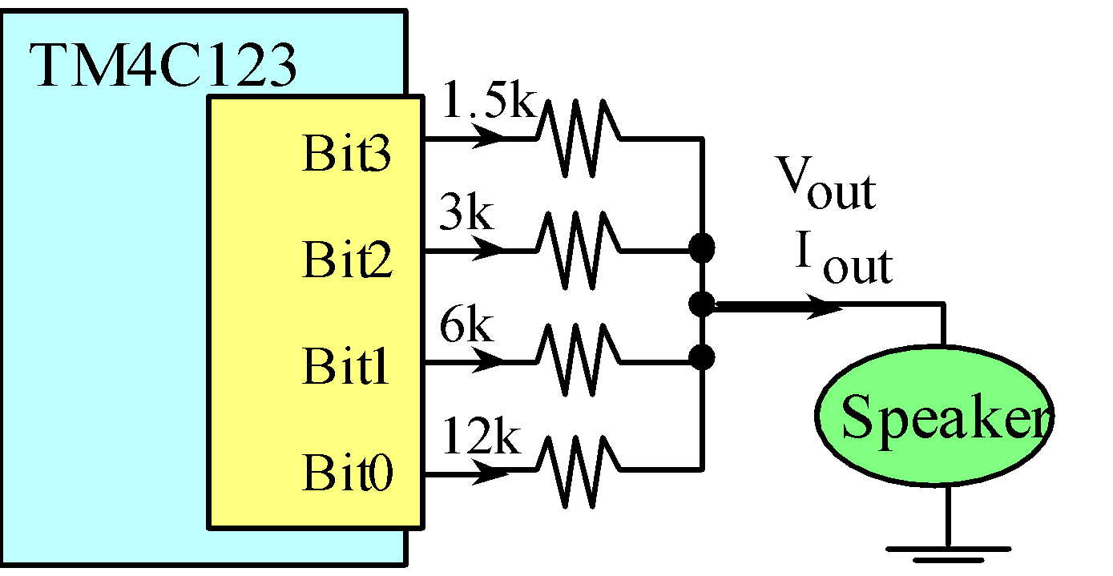

  Connect the OLED to the microcontroller as described in Lab 7.

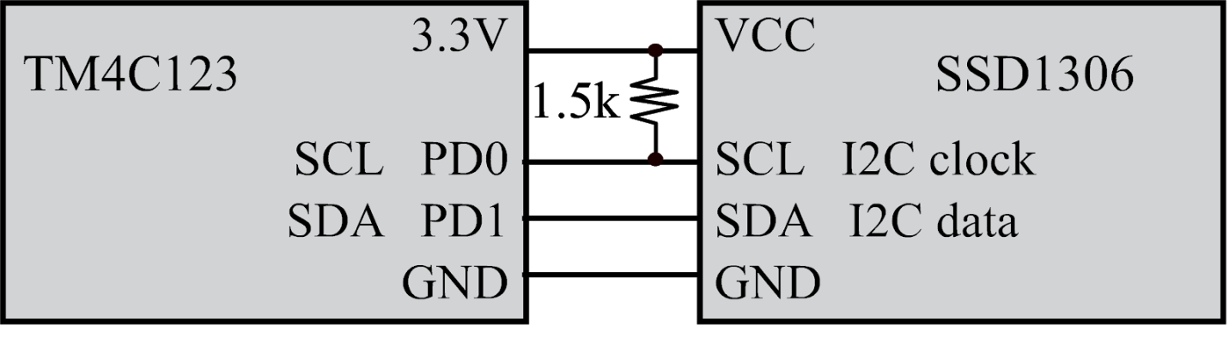

*Figure 7.2. Interface connections for the SSD1306.*

  Connect the Slidepoit to the microcontroller as described in Lab 8.

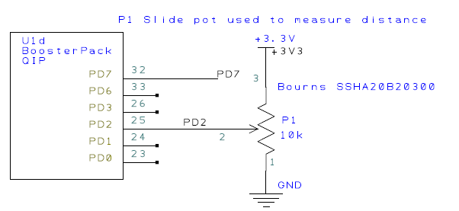

*Figure 8.1. Possible circuit to interface the sensor (use your ohmmeter on the sensor to find pin numbers 1,2,3).*

To use the TExaS oscilloscope, also connect a testpoint to PD3, allowing you to connect PD3 to either DACOUT or to PD2 (slide pot in)

Lab 9 does not need any circuits. Please avoid using PC4 and PC5. However as an option, you could connect PC4, PC5, GND to a 3-pin header. We can then place a shorting jump across PC4 to PC5 to complete Lab 9 (socially distancing). Or in Lab 10 you can use two boards with a 3-pin cable connecting PC4-PC5 PC5-PC4 and GND-GND.

Lab 10 uses Labs 3,6,7,8,9 into one project

Avoid PB7 because it is connected to PD1. Avoid PB6 because it is connected to PD0.

**Assignment 2:** Layout EE319K/EE319H circuits in Eagle for labs 6,7,8,9,10 in one PCB file less than 10 square inches. Specifications for OSHpark can be found at

<https://docs.oshpark.com/services/two-layer/>

Specifications for JLCPCB can be found at  
<https://jlcpcb.com/capabilities/Capabilities>

During layout you want to consider how the system will be used to create a hand-held game, placing display, slidepot, and buttons in positions to make game fun to play.

**PCB production**

Oshpark <https://oshpark.com/>

1) Pass DRC on Eagle PCB

2) Upload eagle PCB file to Oshpark

JLCPCB <https://jlcpcb.com>

1) Pass DRC on Eagle PCB

2) Put **jlcpcb_2_layer_v9.cam** file in

Users\your_user_name\Documents\EAGLE\cam folder

<https://support.jlcpcb.com/article/22-how-to-generate-the-gerber-files>

3) Create Gerber files,

4) Upload Gerber.zip file to JCLPCB